Step-by-Step Execution (With Screenshot Guidance)

Step 1: Install HTTPD on App Server 1 (stapp01)
- SSH into app server 1 from jump host
- Switch to root user
- Install httpd package
- Update Apache to listen on port 8080
- Start and enable the service
- 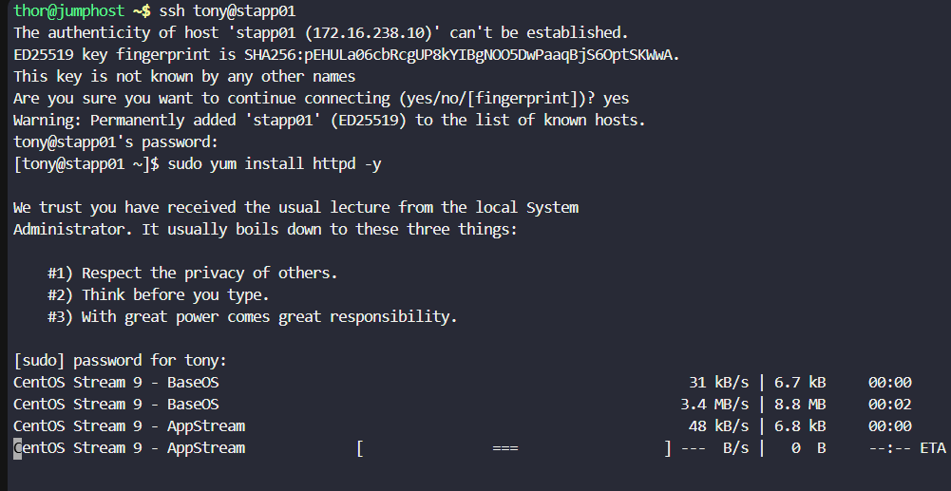SSH session showing yum install httpd
- httpd.conf with Listen 8080
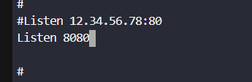
- systemctl start and enable output
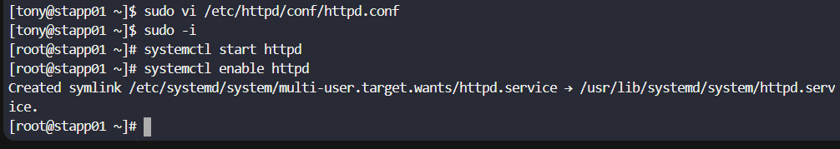

Step 2: Repeat HTTPD Setup on App Server 2 (stapp02)
- SSH into stapp02
- Become root user
- Install and configure httpd
- Start and enable service
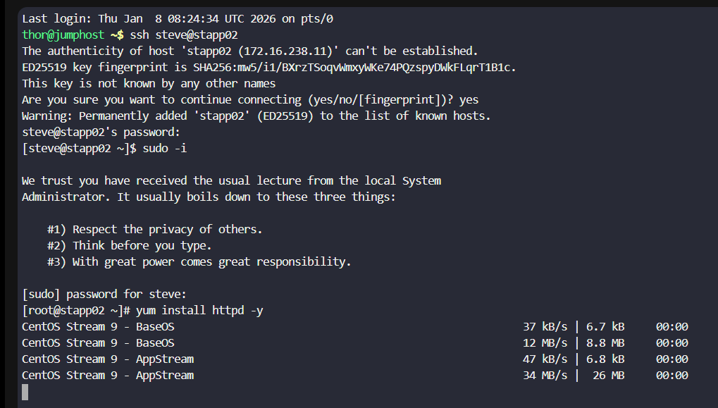
- SSH login to stapp02
- Successful HTTPD installation and service status
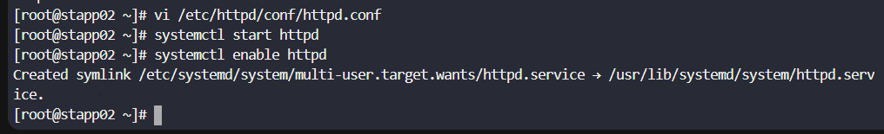

Step 3: Repeat HTTPD Setup on App Server 3 (stapp03)
- SSH into stapp03
- Install and configure httpd
- Start and enable the service
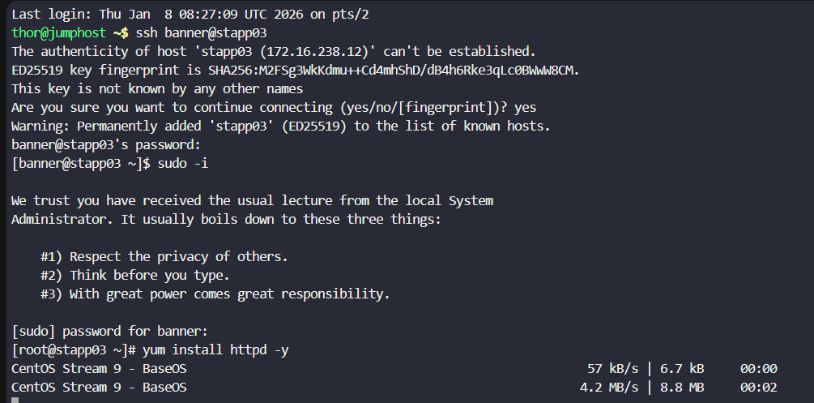
- SSH login to stapp03
- httpd running and enabled
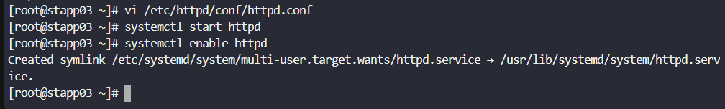

Step 4: Update Ownership on Storage Server
- SSH into storage server as natasha
- Change ownership of /var/www/html to user sarah
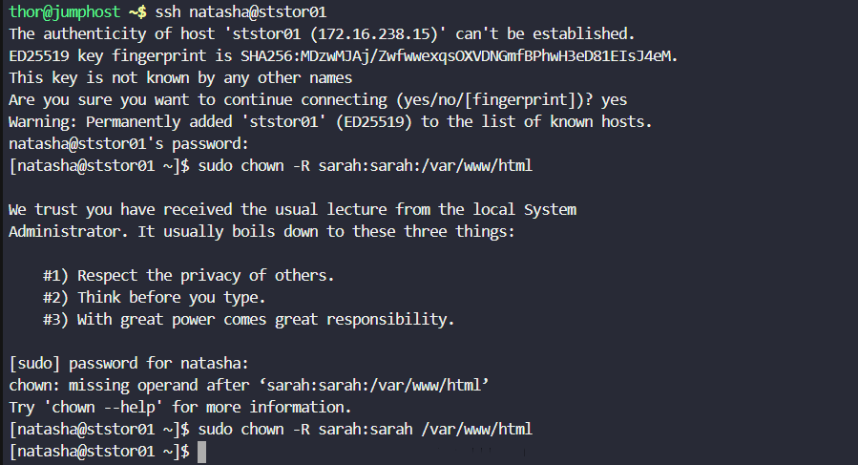
- chown -R sarah:sarah /var/www/html command and success

Step 5: Log in to Jenkins
- Open Jenkins UI using the provided button
- Log in using admin credentials
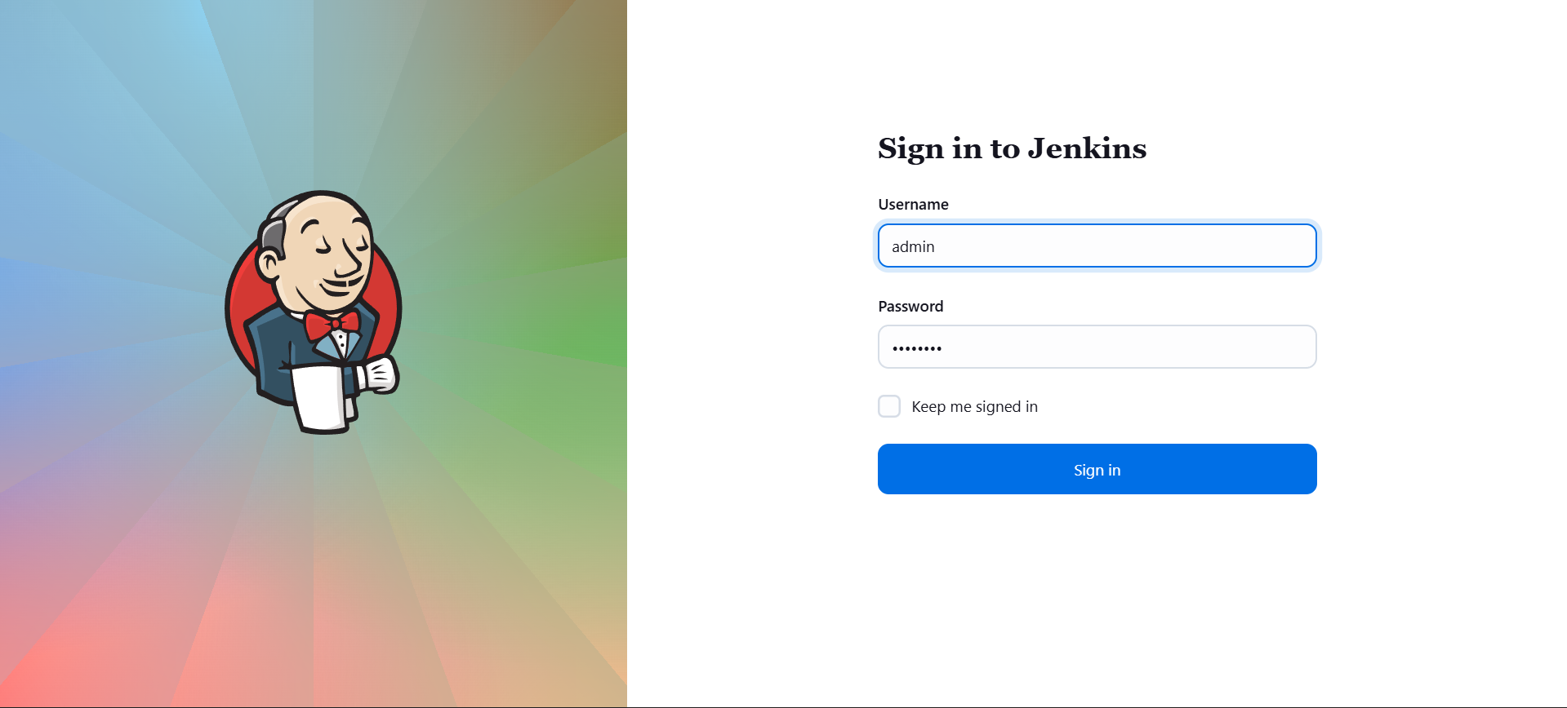
- Jenkins login page
- Jenkins dashboard after login

Step 6: Install Required Jenkins Plugins
- Navigate to Manage Jenkins → Plugins
- Install:
  - Credentials Plugin
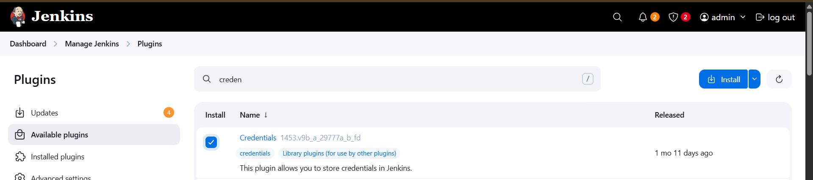
  - Git Plugin
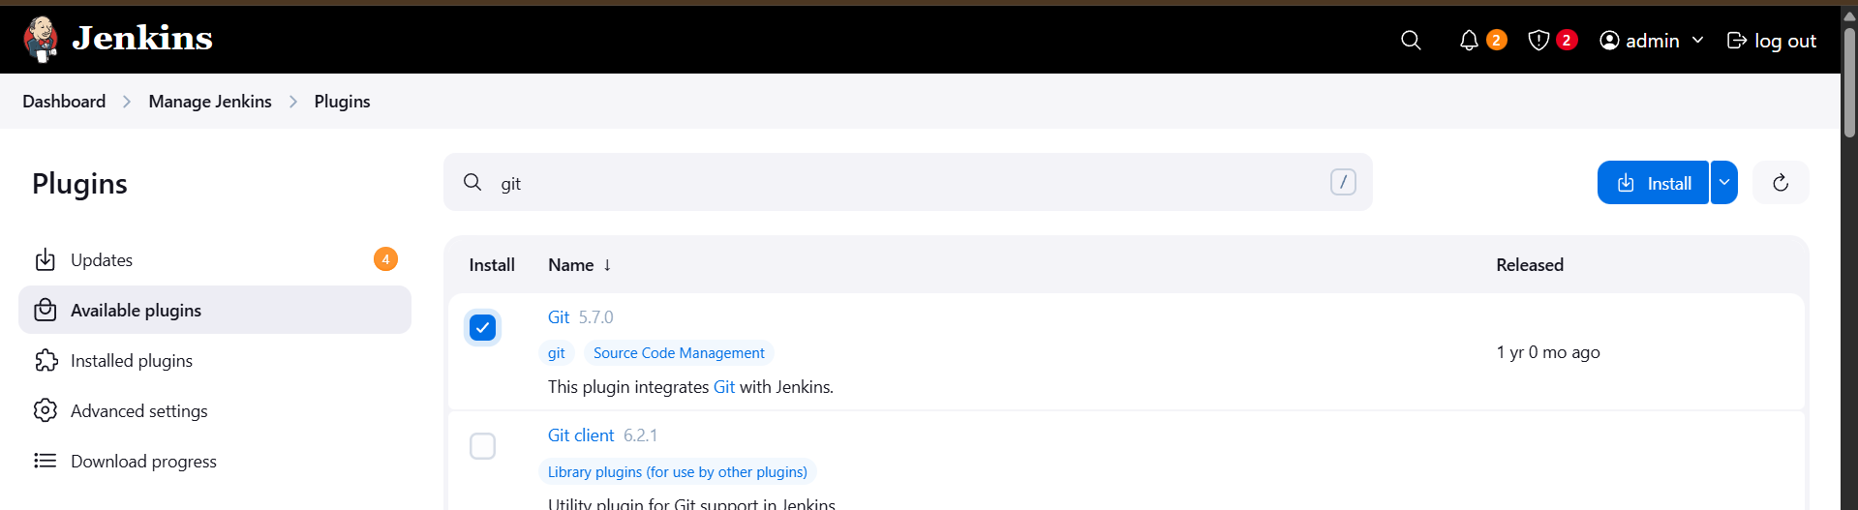
- Restart Jenkins after installation
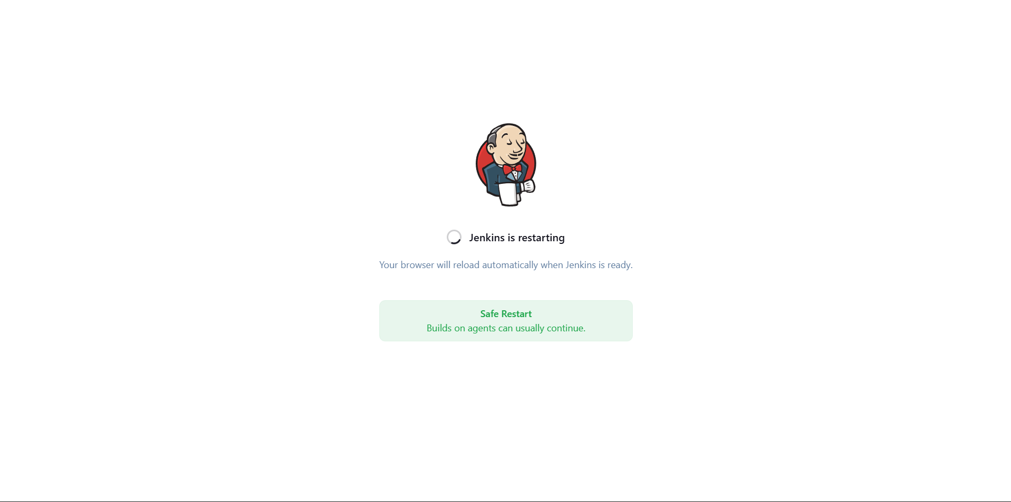
- Plugin installation page
- Jenkins restarting screen

Step 7: Configure Jenkins Credentials
- Add Username & Password credential for Git
  - Username: sarah
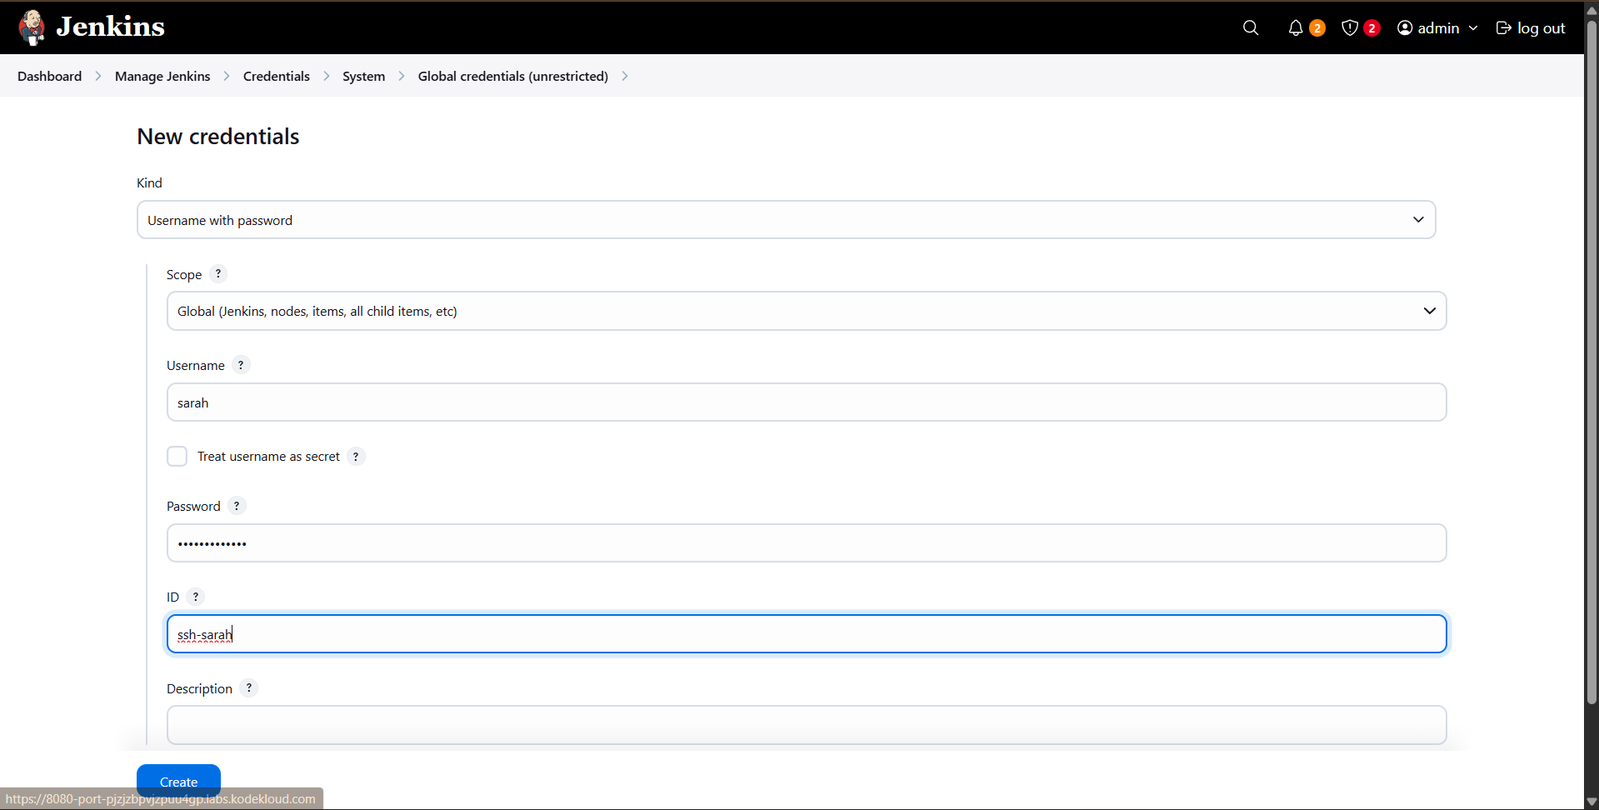
- Add Secret Text credential
  - ID: sarah-secret
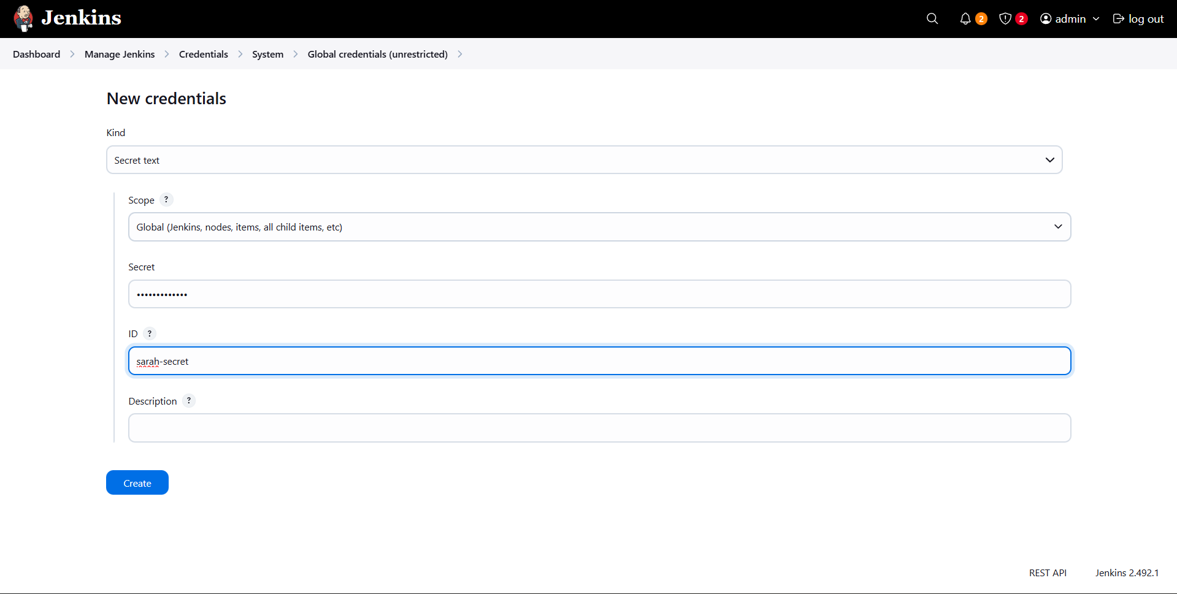
- Credential creation forms
- Credentials list showing both entries

Step 8: Create Jenkins Job
- Create a new Freestyle Project
- Job name: nautilus-app-deployment
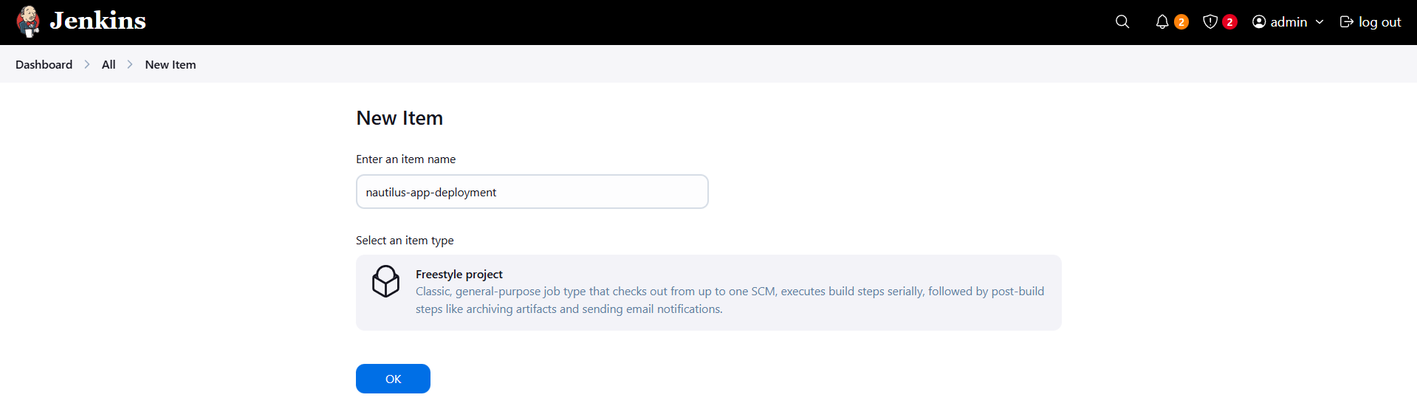
- New Item screen with job name
- Freestyle project selection

Step 9: Configure Source Code Management
- Select Git
- Repository URL:
http://git.stratos.xfusioncorp.com/sarah/web.git
- Select sarah credentials
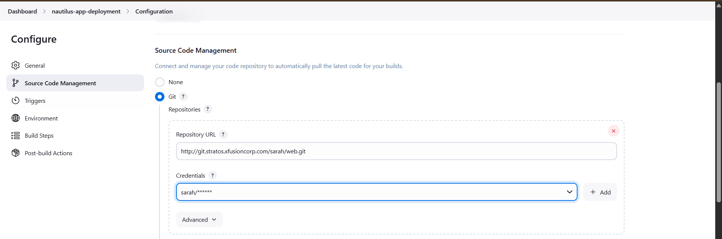
- SCM configuration section

Step 10: Configure Build Trigger
- Enable Poll SCM
- Schedule:
- * * * * *
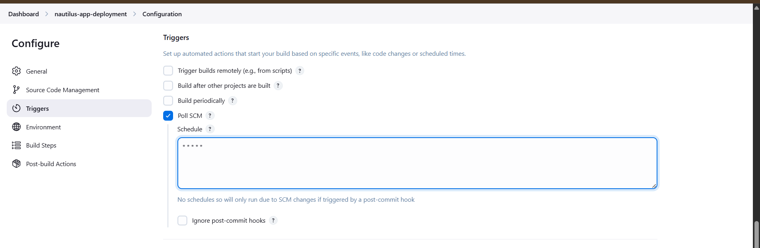
- Poll SCM configuration

Step 11: Configure Environment Variables
- Enable Use secret text(s)
- Variable name: SARAH_PASS
- Credential: sarah-secret
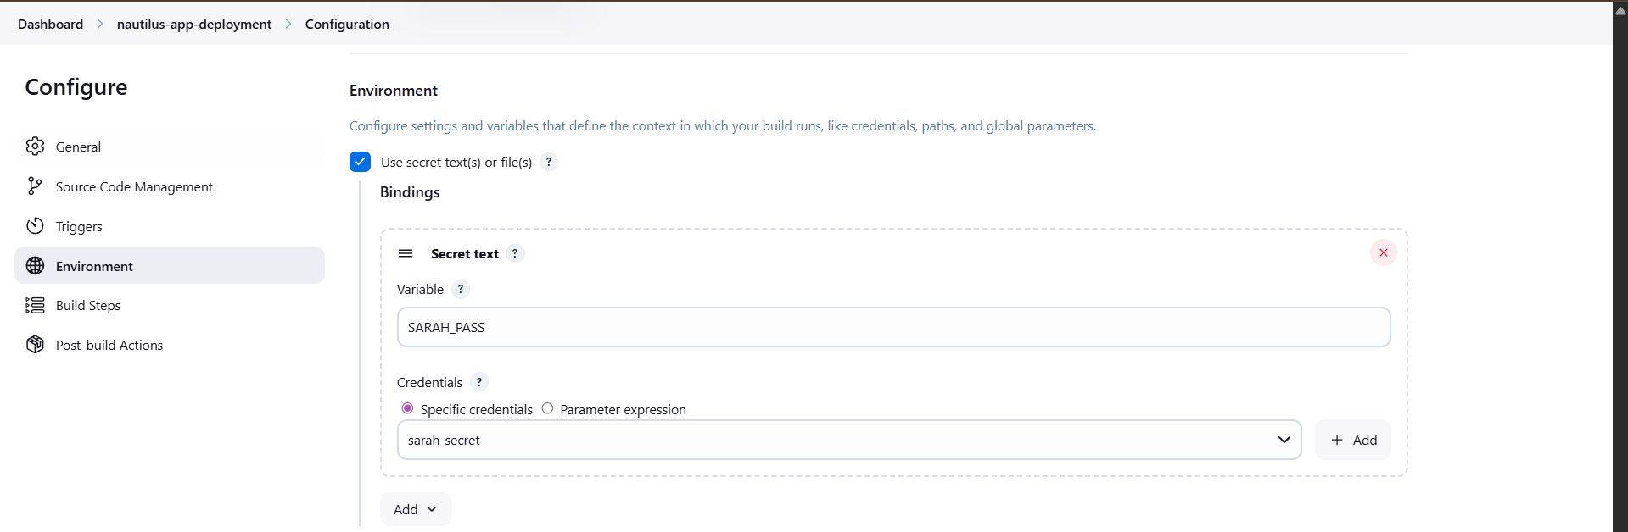
- Environment configuration page

Step 12: Configure Build Step
- Add Execute Shell build step
- Use SCP with sshpass to deploy files
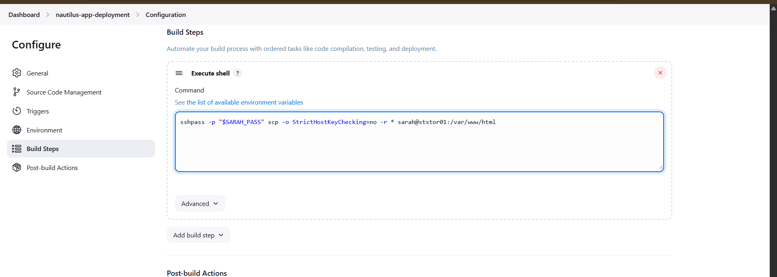
- Execute shell command section
- sshpass -p "$SARAH_PASS" scp -o StrictHostKeyChecking=no -r * sarah@ststor01:/var/www/html

Step 13: Modify Application Code
- SSH into storage server as sarah
- Navigate to web directory
- Update index.html with required message
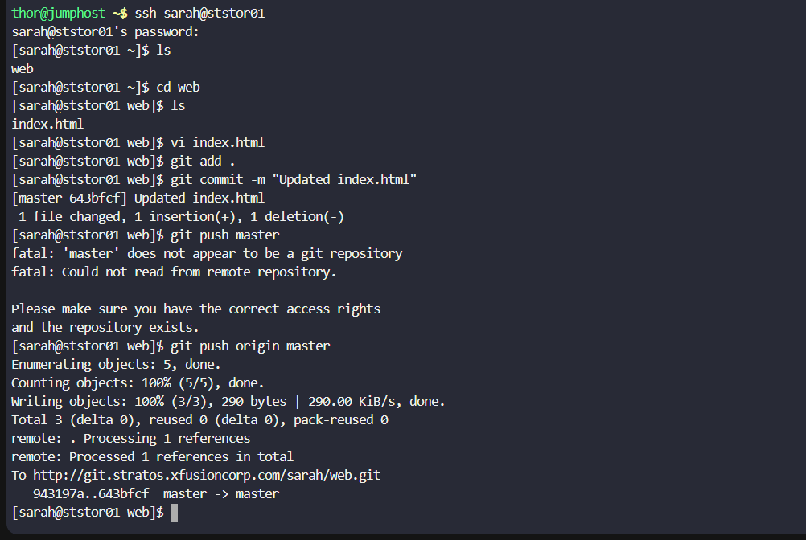
- Editing index.html showing text:
Welcome to the xFusionCorp Industries
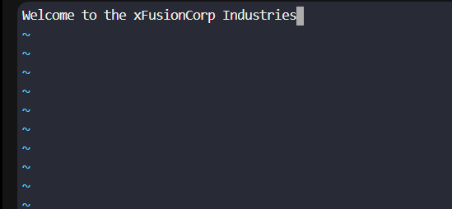

Step 14: Commit and Push Changes
- Add changes to Git
- Commit with message
- Push to master branch
- git add, commit, and push output

Step 15: Verify Jenkins Build
- Confirm Jenkins job triggered automatically
- Check console output for success
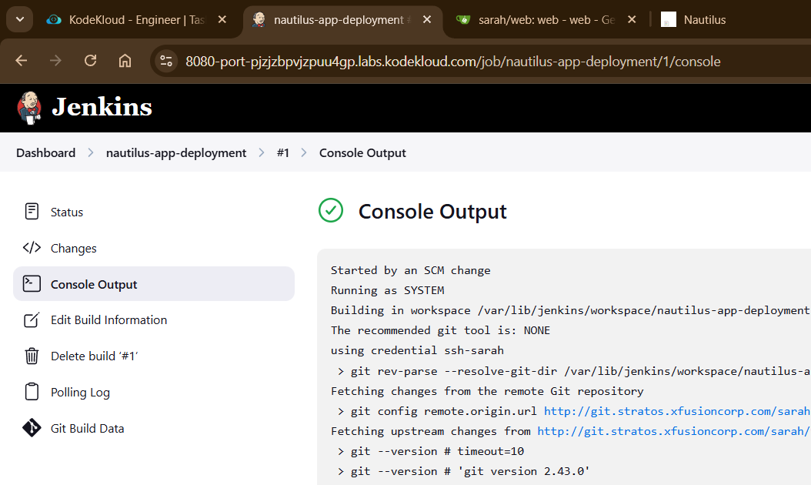
- Jenkins console output with successful build

Step 16: Validate Application
- Open application URL (port 8080)
- Verify updated content is visible
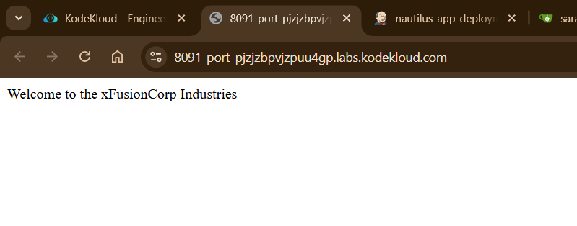
- Browser showing:
Welcome to the xFusionCorp Industries

